**Ensighten – API Development Document**

**Github URL :** [**https://github.com/arunsk12/akumar.git**](https://github.com/arunsk12/akumar.git)

**Service URL :** [**http://localhost:8080/car**](http://localhost:8080/car)

**Using a http requestor or curl command post the json to the service with the above url.**

Few examples given below.

*{ "model" : "iQ", "make" : "Toyota", "yearOfManufacture" : "01/01/2010", "entryDate" : "01/01/2008" }*

*{ "model" : "Verso", "make" : "Toyota", "yearOfManufacture" : "01/01/2011", "entryDate" : "01/01/2007" }*

*{ "model" : "Civic", "make" : "Honda", "yearOfManufacture" : "05/05/2011", "entryDate" : "01/01/2004" }*

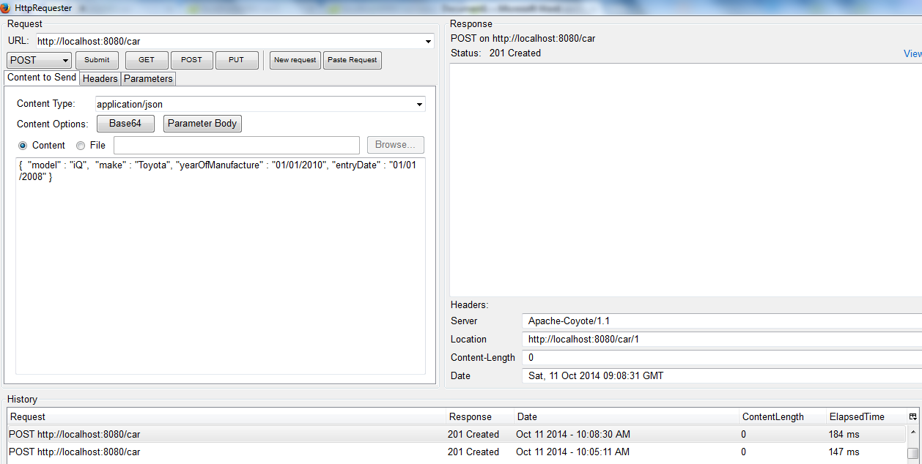

**URL to find the first car entry :** [**http://localhost:8080/car/1**](http://localhost:8080/car/1)

{

"model" : "iQ",

"make" : "Toyota",

"yearOfManufacture" : "01/01/2010",

"entryDate" : "01/01/2008",

"_links" : {

"self" : {

"href" : "http://localhost:8080/car/1"

}

}

}

**URL to search the contracts available in the service :** [**http://localhost:8080/car/search**](http://localhost:8080/car/search)

{

"_links" : {

"findByMake" : {

"href" : "http://localhost:8080/car/search/findByMake{?make}",

"templated" : true

},

"findByModel" : {

"href" : "http://localhost:8080/car/search/findByModel{?model}",

"templated" : true

}

}

}

**URL to search by Model :** <http://localhost:8080/car/search/findByModel?model=iQ>

**URL to search by Model :** <http://localhost:8080/car/search/findByMake?make=Toyota>

**Please use the “PUT “ to replace, “PATCH” to update and “DELETE” http verbs to the REST calls to either replace, update, or delete the existing records.**

*curl -X PATCH -H "Content-Type:application/json" -d '{"model" : "iQ", "make" : "Toyota", "yearOfManufacture" : "01/01/2010", "entryDate" : "01/01/2008" }' http://localhost:8080/car/1*

*curl -X PUT -H "Content-Type:application/json" -d '{"model" : "iQ", "make" : "Toyota", "yearOfManufacture" : "01/01/2010", "entryDate" : "01/01/2008" }' http://localhost:8080/car/1*

*curl -X DELETE -H "Content-Type:application/json" -d http://localhost:8080/car/1*